INFORMED CONSENT FORM FOR A CLINICAL TRIAL WITH AN INVESTIGATIONAL VACCINE IN ADULT HEALTHY VOLUNTEERS
[Add:] Official lay title of the trial as given in the EUDRACT data base

Introduction

You are invited to take part in a clinical trial. The aim of this trial is to study <vaccine> that <has been/is being> developed by <name of company>.

This informed consent form (ICF) describes the trial and what participating may mean for you. The trial staff will explain the trial in this informed consent form. Please ask them about anything you do not understand. [optional: You are welcome to bring a family member, friend, or someone you trust to the conversation.]

Before you decide to join the trial, we recommend you talk about it to anyone you trust, such as a family member, friend or your general practitioner (GP). Please read this document carefully and take as much time as you need to make your decision.

The documents related to the trial have been reviewed and approved by the Belgian competent authorities and an independent Ethics Committee. This is done for all clinical trials and as a result should not influence you when deciding whether to take part in this trial.

If you agree to join the trial, you will be asked to sign this informed consent form. We recommend you let any physician in charge of your health know if you do participate. For example, this could be your general practitioner (GP).

What is the purpose and the design of the trial?

[Consider covering the following topics:
- What is the disease?
  - Why is there a need for a vaccine?
- Brief description of the trial design + visual
- Has the vaccine been tested in humans?
- For Human challenge trials: info about the administered pathogen.
- In the case of a vaccine developed against an infectious disease: specify whether the vaccine contains an attenuated or inactivated live organism.
- The aim of this trial (adapt as necessary)
  - Safety
  - Dose finding
  - How the vaccine works
  - Most efficient route of vaccination
  - Co-administration with other vaccines
  - Efficacy/comparison with another vaccine or placebo
  - Used adjuvant
- Inclusion/exclusion criteria or proposed option to include the sentence “the investigator or the trial staff will discuss with you the conditions to participate”
- Explain the follow-up phase of the trial in case of adverse events.
- If you use the term “Placebo” or other difficult words, please ensure the meaning is explained in lay-language.
Proposed example text:
Every year tuberculosis affects 10.4 million people, causing human suffering. There is currently a vaccine against tuberculosis, but it protects only infants and very young children. That is why there is a need for a new vaccine that will protect adolescents, adults and older people.
We will first test your blood to see if you meet the trial requirements. If you meet the entry criteria for the trial, you will be given either the vaccine or a placebo. A placebo looks just like the vaccine and is given the same way but has no active ingredient in it. This will be chosen at random (just like rolling dice) (see image 1). As the trial is double blind, neither you nor the trial staff will know whether you received the vaccine or the placebo. In case of a health issue, the trial staff can find out what you received. This is the first time this vaccine is tested in humans. This trial will help us determine the correct dose of the vaccine. During the trial we will follow up on your health condition every 3 weeks for 6 months.]
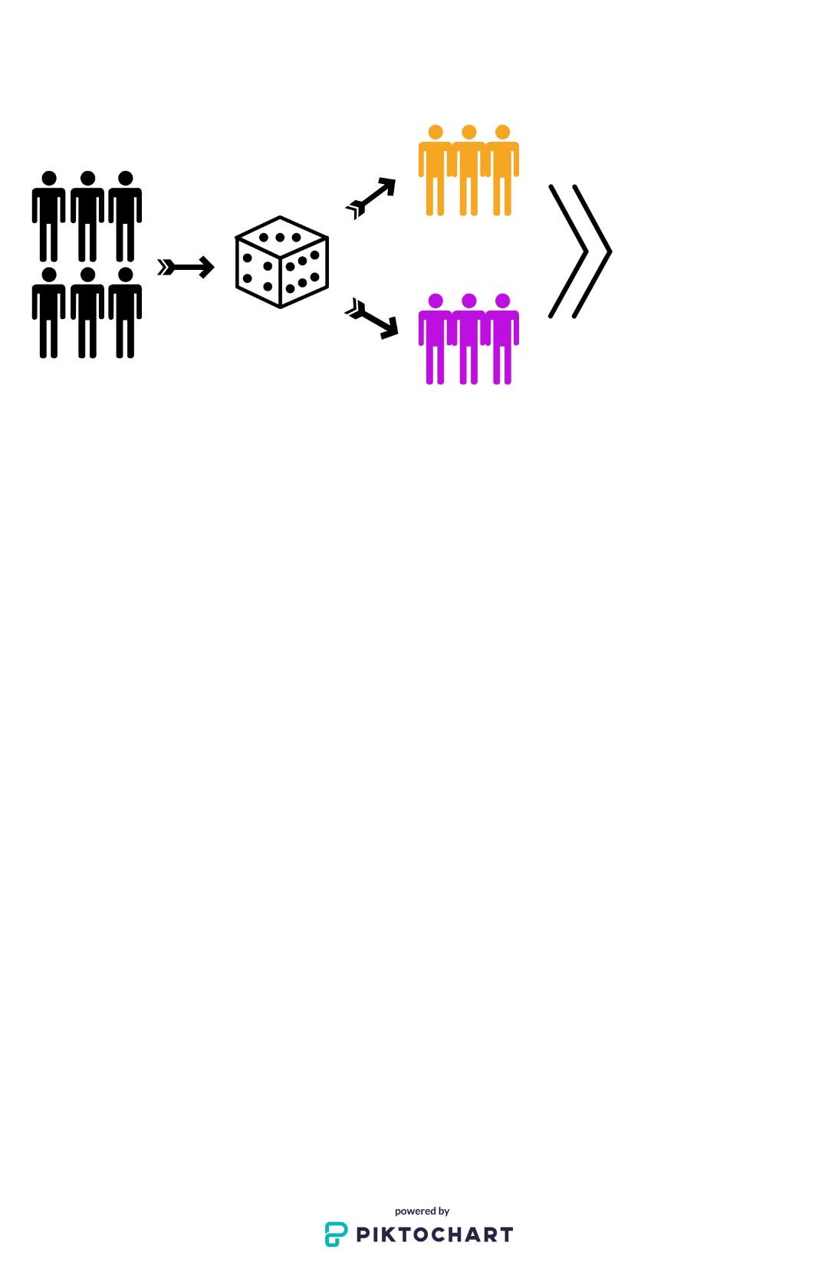 | Collection and analysis of trial data
Image 1: All the participants will be randomly chosen to receive one of the trial treatments.

What will happen during the trial?

[The table below is an example. Depending on the trial design this table can be adapted or a more appropriate format for the study applied].
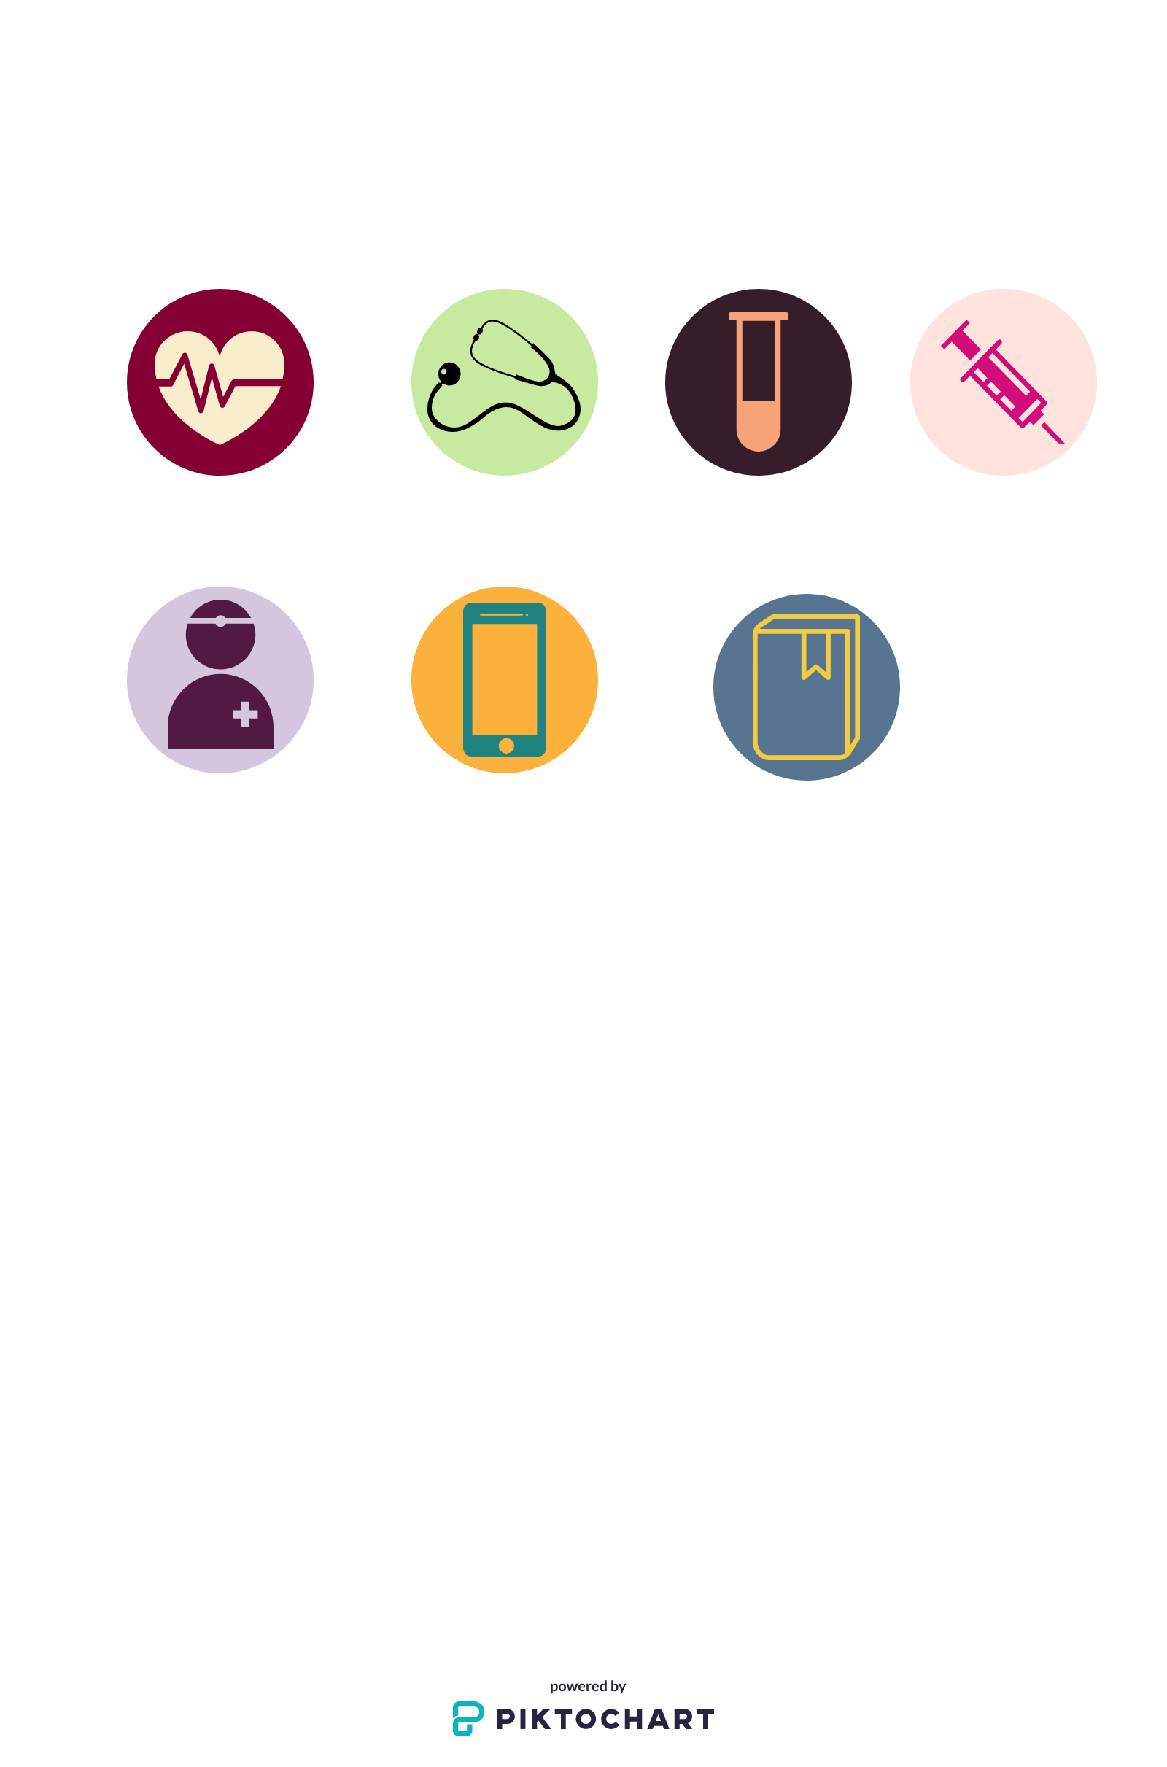  You will be asked questions about your health by the trial staff. | The trial staff will perform tests to check your health while you are taking part in the trial
Blood samples will be drawn. [Insert information about any other samples taken, including additional samples]. For this trial the overall volume of blood to be taken will be <xxx> ml. | You will get <X> doses of the vaccine [if applicable: or placebo] at  <Y months/weeks/days>
Follow the trial staff's instructions | 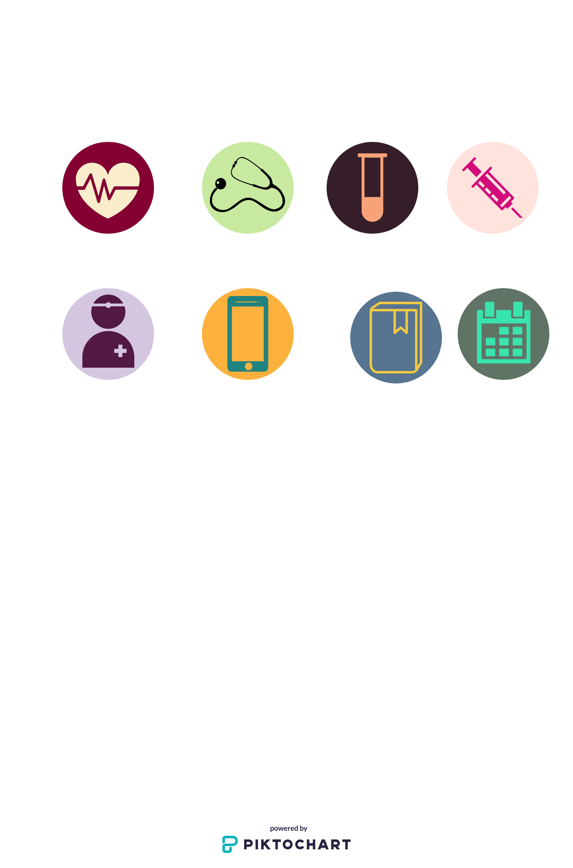  You will need to come to the trial site <X> times.
You will be asked to complete electronic and/or paper diary cards for your safety.


<A> pregnancy test(s) will be performed. <Blood, urine> will be collected before the first dose of <vaccine>. [If applicable, choose: If you miss your period, notice that it is late or irregular, you will be asked to take another (urine) pregnancy test. [OR:] You will have to take a (urine) pregnancy test at defined timepoints during the trial.]

 | Screening visit | Visit x (date) | Visit x (date) | Visit x (date) | Visit x (date) | Visit x (date) | Visit x (date)
Health questions | 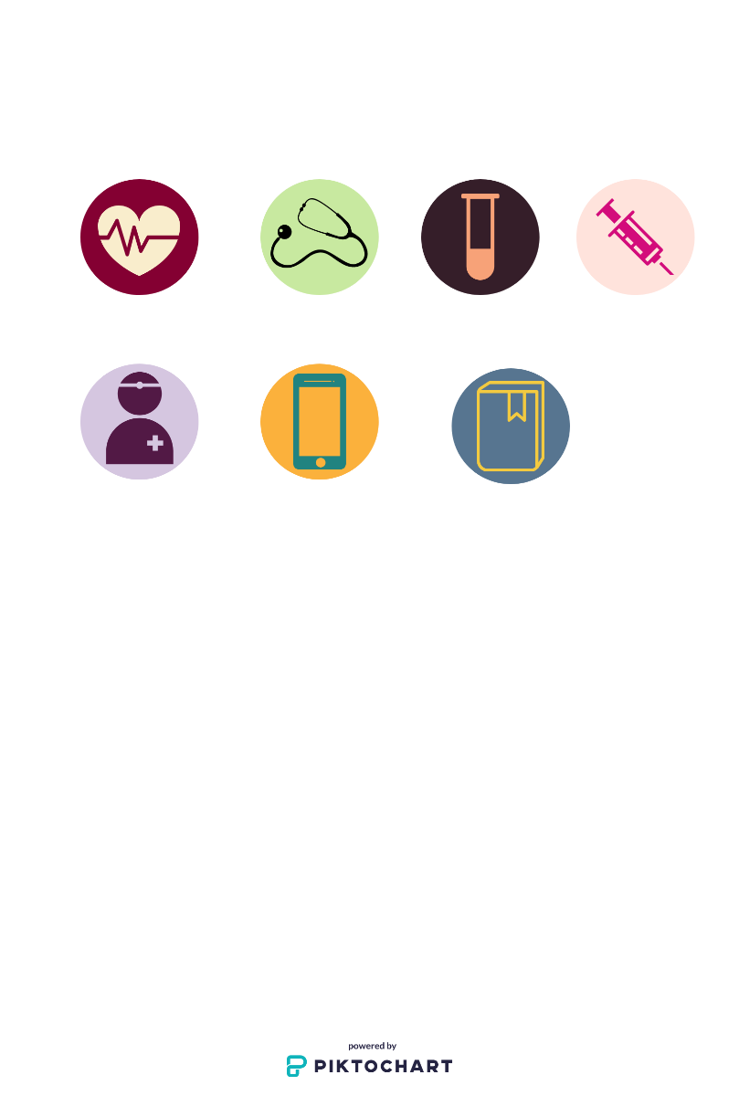 | 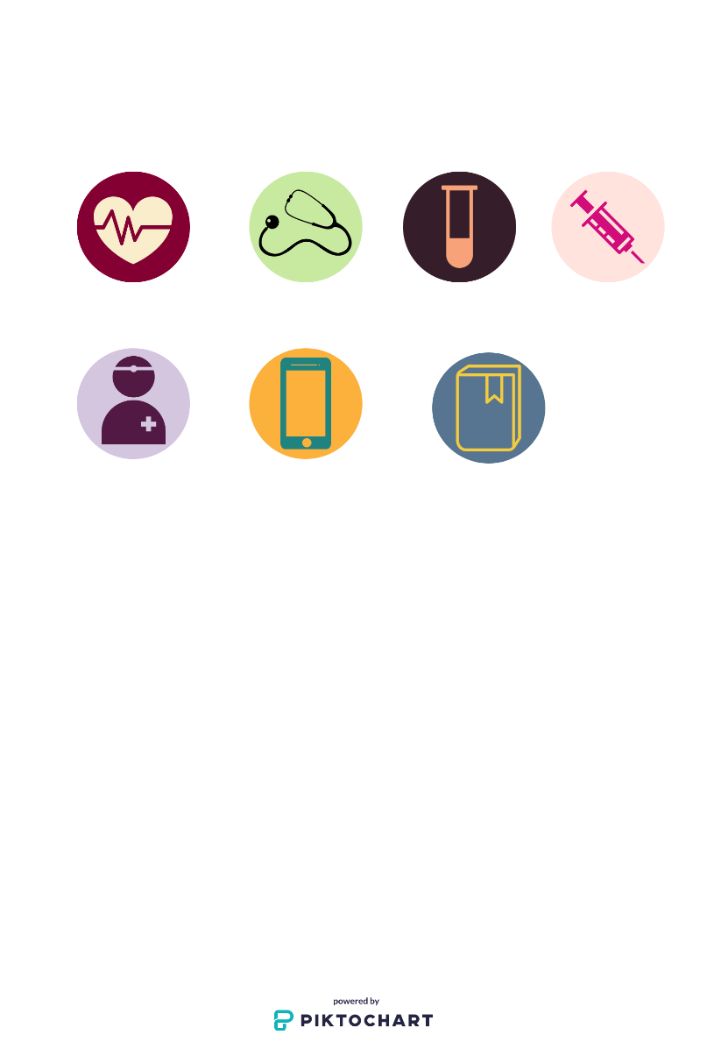
Physical exam | 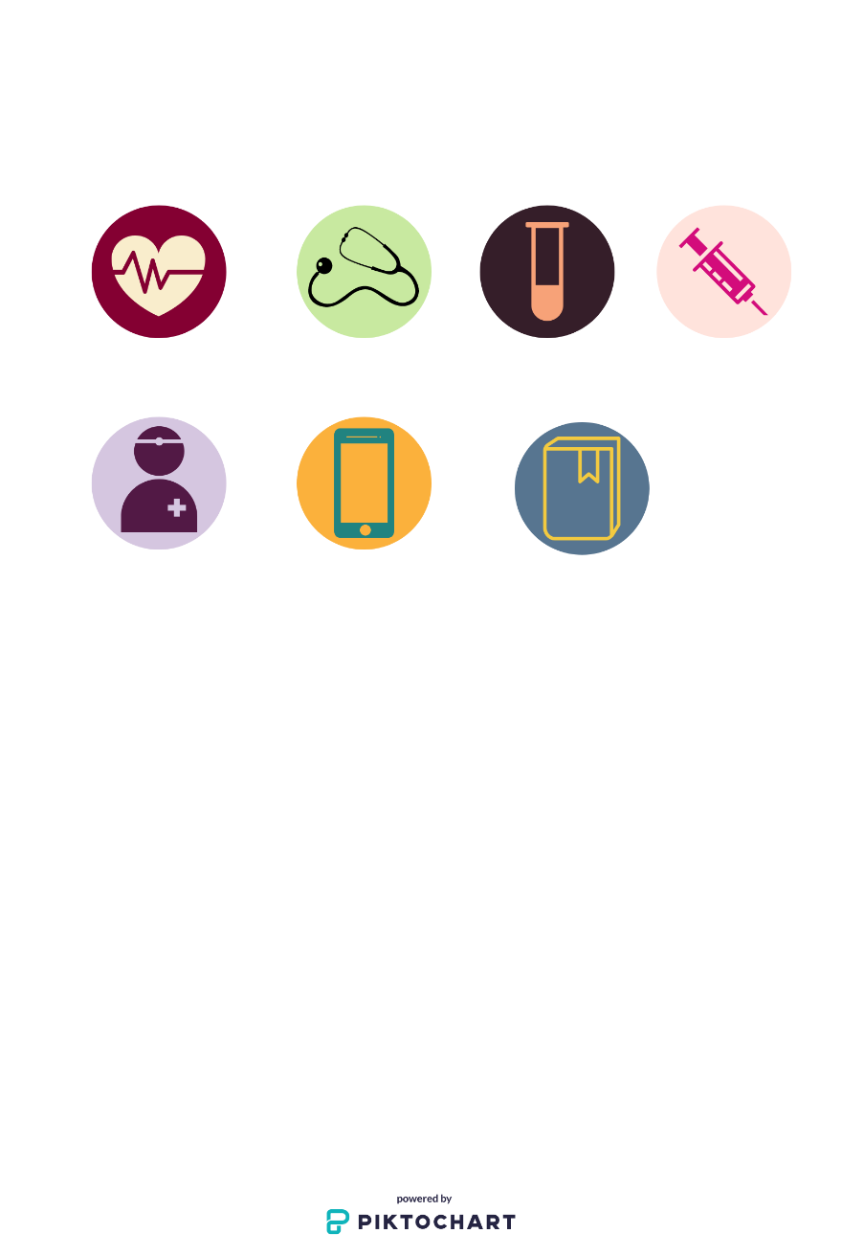
Vaccination |  | 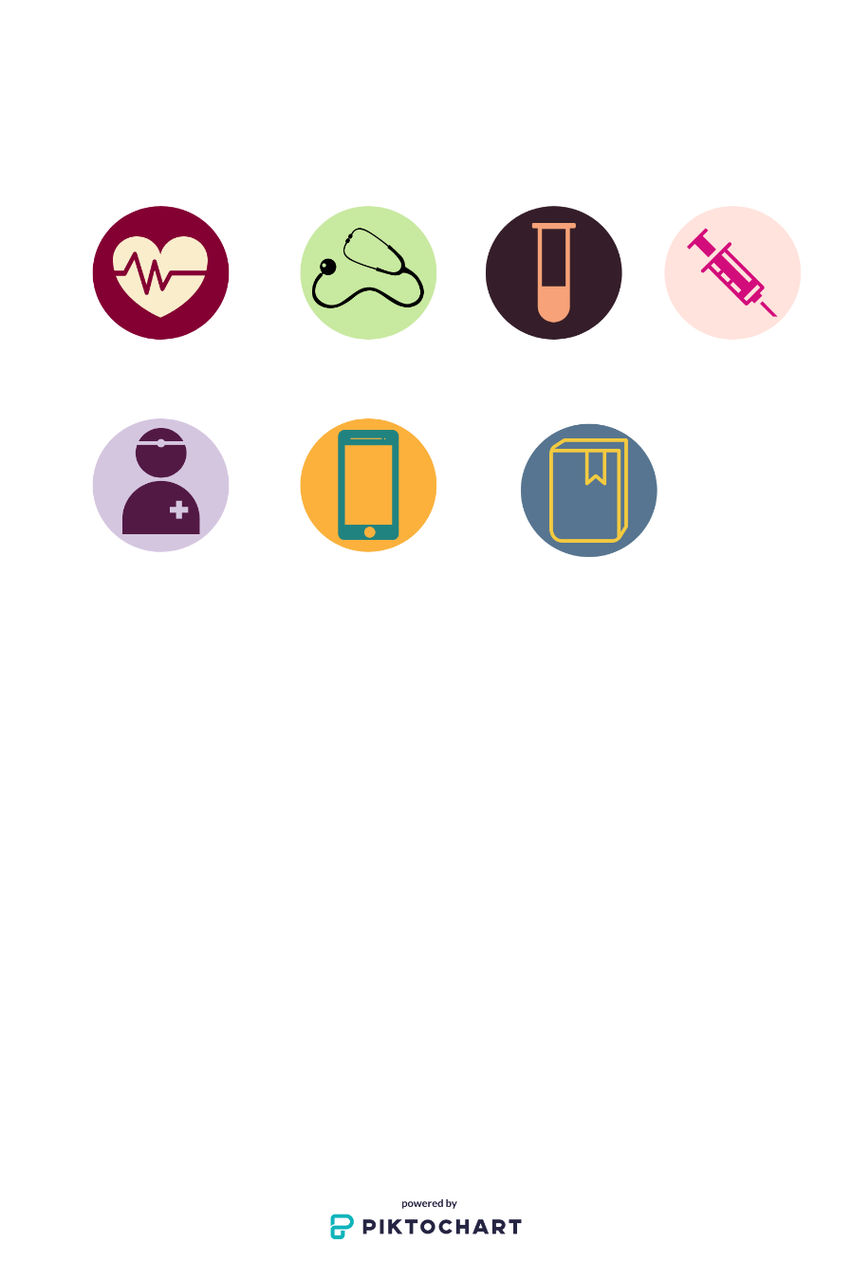
Sample collection (if applicable with volume) | 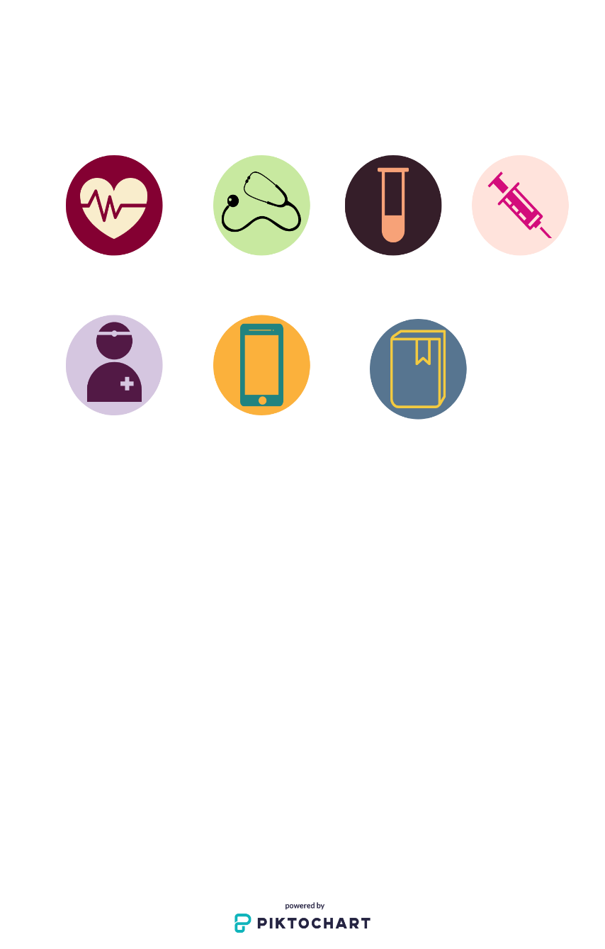
Return of e-diary |  |  |  |  |  | 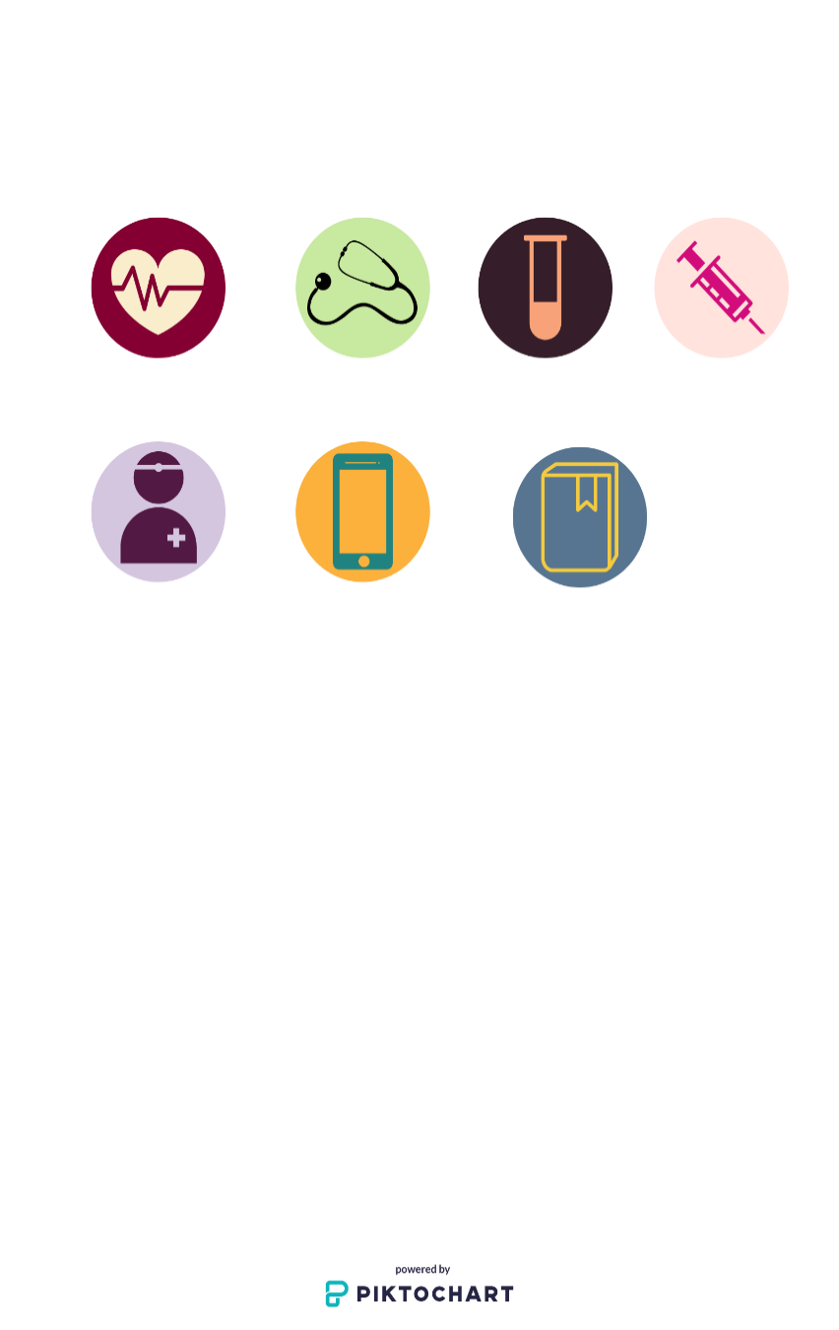
Return of paper Diary Card |  |  |  |  | 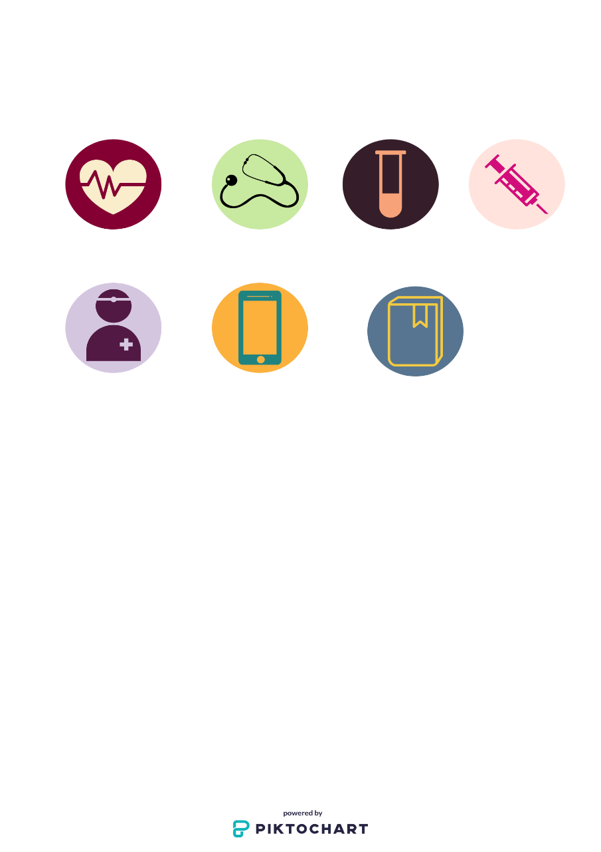
Pregnancy Test | 
Approximately <X> months

What are the restrictions, as well as the potential risks and discomforts?

There are known discomforts, or risks of side effects that can happen with the use of a vaccine. There might be other side effects that are not known at this time. You may also feel discomforts related to the procedures. The trial staff are trained to take the right measures to reduce risks and limit any discomforts you may experience. If new information becomes available that may influence your decision to continue to participate, the trial staff will let you know. In this case, you will be asked to sign a new consent form.
Below you will find the discomforts and risks associated with receiving the <vaccine> that have been observed in [Choose:] previous trials [OR:] animal studies. It is possible that you might have them as well. If you experience any side effects, let the trial staff know.
[Sponsors are to decide the extent of information on risks to be included. It is possible to represent the information in various ways. Below are 2 examples you can consider using. Please feel free to use a different one that suits you better. If reference to animal data is included, add that these are not always applicable to humans. Frequency may not be available for early phase trials.]
Examples:
Investigational Vaccine <name of vaccine>
[Example 1]
Observed common reactions: [add list]
The following reactions have also been observed: [If applicable: add list with frequency, e.g. redness at the site of injection may affect up to 1 in every 100 people]
Discomforts and restrictions related to procedures/trial: e.g. no alcohol intake, pain at site of injection, bruising of vein due to blood sampling, etc.
[Example 2]
You may experience the following side effects:
Very Common: | In more than 1 in 10 participants:  Pain, redness and swelling at site of injection
Common: | Between 1 in 100 and 1 in 10 participants:  Muscle pain, tiredness, headache
Less common: | Between 1 in 1,000 and 1 in 100 participants:  Shivering, pain, nausea, vomiting, diarrhoea, upset stomach
Rare: | Between 1 in 10,000 and 1 in 1,000 participants:  Dizziness
Very Rare: | Between 1 in 100,000 and 1 in 10,000 participants  Severe allergic reaction

You may/will also experience the following discomforts/restrictions during the trial/procedures [adapt to include trial specific procedures]
Procedure | Discomfort and restrictions
General participation in trial | No alcohol intake
Blood sampling | Pain, bruising, redness of vein at sample site
Vaccine/Placebo administration | Pain and redness at injection site

Comparator vaccine/adjuvant/placebo:
[Add a list of the side effects and describe them briefly, as described above. If a reference vaccine is involved, please refer to the risk section of the leaflet of this vaccine.]

[For Human challenge trials, also include the risks of the pathogen.]

What do I need to know about contraception, pregnancy, and breastfeeding?
[Adapt this section as per study requirements]
[If applicable] Female participant:
[Optional: It is not known whether receiving <vaccine> could have an effect on the unborn child or baby.] If you are pregnant or breastfeeding or if you are planning to become pregnant during the trial, you cannot participate.

If you are female, sexually active with a man and can have children, you and your partner will have to use [sponsor specific: add here list of allowed methods of birth control]. You must use one of these allowed methods of contraception from at least <xxx days> before vaccination until <xxx days> after the last dose of the <vaccine>.

[If applicable:] You will also not be allowed to donate your eggs/ovum during the trial and for <xxx days> after the last dose of the <vaccine>.

If you become pregnant during the trial, you should tell the trial staff right away. The investigator will then discuss the options with you [optional: and your partner]. [Optional: The investigator will ask you to sign a specific informed consent (for the pregnant participant) to follow up on your pregnancy and its outcome.]

[Optional in case of risk:] Male participant:
Receiving <vaccine> could have an effect on your sperm and could lead to an unknown risk for an unborn child. If your partner is planning to become pregnant during the trial, you cannot take part.

If you take part in the trial, you and your partner will have to use [sponsor specific: include here list of allowed methods of birth control] for preventing pregnancy. You must use one of these allowed methods of contraception from at least <xxx days> before vaccination until <xxx days> after the last dose of the <vaccine>. You should agree not to donate sperm up to <xxx days> after the last dose of the <vaccine>.
You agree to commit to tell your female partner that you are taking part in this trial, and to tell her that there may be risk to an unborn child.
If your partner becomes pregnant during the trial, you should tell the trial staff right away. The investigator will then discuss the options with you [optional: and your partner]. [Optional: You or your pregnant partner will be asked to sign a specific informed consent to follow up the pregnancy and its outcome.]

What are the potential benefits?

There may or may not be a personal health benefit to you if you take part in this trial.
The results of the trial will help learn about the <disease> and whether the <vaccine> works or not.

Are there any alternative vaccines and/or treatments?

Currently for [choose: disease [or] infection] [choose: there are no available alternative vaccines and no medicinal treatment [or] there are no available alternative vaccines], but the [choose: disease [or] infection] is treated by [choose: <add here how it is treated> [or] vaccine <add here name of vaccine> is available]
If a new vaccine becomes available, the investigator will discuss this new information with you. You can then decide to leave the trial and receive the new vaccine if you wish.

Will I receive compensation for my participation?

The sponsor has agreed to pay the trial site for the conduct of the trial and covers the costs of this trial. You or your health insurer will not need to pay anything to participate in this trial.
[All compensation should be mentioned here. Some examples are mentioned below as a guidance. If needed, they can be adapted to trial specific requirements.]

You will receive [optional: up to] <xxx euros> for your participation when the trial is completed.
Should your participation be ended prematurely, the compensation may be adapted.
In addition,
- you will be reimbursed [optional: up to] <xxx euros> for < travel expenses>.
- you will receive [optional: up to] <xxx euros> per visit.
- you will receive [optional: up to] <xxx euros> per meal.
[Optional:] Since you have to use a specific method of contraception for this trial, it will be reimbursed.
[Add any additional relevant information.]

The trial staff will inform you about the practical arrangements.

What if something goes wrong?

Even if there is no fault, the sponsor is liable for any damage you suffered that is directly or indirectly related to your participation in the trial. The sponsor has taken an insurance called ‘No Fault Insurance’ for this situation. This means you do not have to provide proof that the investigator or trial staff made a mistake. A copy of the insurance certificate can be obtained from the trial staff.
In case you suffered any damage, you must inform the trial staff as soon as possible.
If the investigator believes a link between the damage you suffered and the trial is possible, he/she will inform the sponsor. The latter will officially inform the insurance company. The insurance company will then decide whether to appoint an expert to find out if there is a link between the damage you suffered and the trial.
At any point if you disagree with the investigator, you can contact the insurance company. If you disagree with the insurance company expert, you can sue the insurer directly. You can find the name and policy number of the insurer at the end of this form.
In the event of your death your rightful claimants (e.g. your wife, husband, children or parents) can do the above.

What will happen to my samples?

As part of the trial, blood samples <list all types of samples> will be taken. Your samples will be given a unique code number (Ref. ). The code number will not identify you directly and will not include your personal information (data).

Your samples will be managed and stored at <add name, city (and country) of the department or company (central lab) managing the biological material for the sponsor)> for <xxx months/years> [optional: and will be destroyed afterwards]. Your samples may be sent to the sponsor laboratories. They may also be sent to other laboratories working on behalf of the sponsor or institutions working with the sponsor. These institutions and/or laboratories may be outside the country where you live. The tracking of your samples will be ensured by the sponsor [if applicable] except for the samples that have been anonymized as described below.

Your samples will be used to [adapt and add any additional points relevant to the trial as necessary]:

- check if you can take part in the trial
- to learn more about the disease(s)
- check the safety of the vaccine and whether it works

Your samples can also be used to perform additional tests, during and after the trial to:
- make sure the quality of the tests used for the investigational vaccine(s) or disease(s) is maintained over time
- develop and improve tests related to the vaccine(s) or disease(s).

[ADD THIS SECTION IF GENETIC ANALYSIS IS PART OF THE TRIAL]

[Choose between the following two options:
The sponsor will perform genetic analysis on your samples. The purpose of this analysis is [explain what the purpose of the analysis is].
[OR]
With your consent additional samples will be collected for genetic analysis. ]

[Choose between the following two options:]
The genetic analysis is optional. If you disagree with having these analyses done, you can still participate in the trial. You will be asked to indicate your choice on the signature page at the end of this document [or] of a separate informed consent form that will describe this research.

[OR]
The genetic analysis may bring important information for the trial. If you disagree with your samples being genetically analysed, you will not be allowed to take part in the trial.

[Optional: You will not be notified of the results of your genetic analysis.]

What happens in case of incidental findings?

During the trial new information about your health might be discovered by chance. This is called “incidental findings”. Such information may be important to you or your blood relatives’ health.

[In case (some) biological samples are not anonymized, choose one of the following options:]
You will not be informed of such incidental findings. If you do not agree with this situation, you cannot participate in this trial.
[Or]
If you agree, the investigator will discuss the results with you. You will be asked to indicate your choice on the signature page at the end of this form.

[In case (some) biological samples are anonymized:]
In this trial <some, your> biological samples will be anonymized. Anonymization means that your biological samples and your personal data cannot be linked to your identity any longer. Therefore, for <those, your> samples you cannot be informed of such incidental findings.

If you do not agree with this anonymization [choose:] your samples will not be included in the optional (genetic) analysis part of the trial [or] you cannot participate in this trial.

[If applicable:]Use of remainders of samples [optional: and additional samples] for future research

If further research is done with remainders of samples, add the following sentence: [Optional: If you agree,] the remainders of your samples may be used for:

If further research is done with additional samples that are being taken, add the following sentence:]
[Optional: If you agree,] <an> additional sample(s) will be taken as described under section 3. These may be used for:

[Adapt as appropriate]:
- Further research related to the vaccine(s) and/or disease(s). This means additional research conducted to understand the vaccine(s) and/or disease(s) better.
- Further research NOT related to the vaccine(s) and/or disease(s). This means additional research conducted to understand other vaccines(s) and/or diseases or for the development of new treatments or research methods. In this case, this research will always have to be approved by an ethics committee.
The results of this further research will [optional: not] be shared with you.
[if optional: Even if you disagree with the optional use of remainders of samples [add if additional samples were taken: and additional samples], you can still join the trial. You will be asked to indicate your choice on the signature page. ]

What happens to my data?

The trial staff will collect data that will identify you. This may include your name, address and phone number. Also data about your health, your medical history, and the results of examinations required by the trial will be collected and processed. All your data collected for this trial will be stored in the trial medical records at the trial site. Below is a table that explains how your data will be handled.
Item | Definition | Who has access?
Non-coded data (Ref. )  (Examples: your name, birth date etc.) | This data is collected by the trial staff to identify and contact you. The data are stored in the trial medical records at the trial site.  Data that may identify you directly will not leave the trial site. | Trial staff  Other people as listed below:  - The sponsor staff who follow up the trial at the trial site.  - An independent audit group  - Inspectors of competent health authorities worldwide  - Representatives of ethics committees  People who see non-coded data are bound by professional secrecy. If they get access to the non-coded data, this will always occur under the responsibility of the investigator.
Coded data  (Examples: data about your health after vaccination, results from tests of your blood samples etc.) | During this trial, you will be assigned a unique code number. All your data that will be sent to the sponsor will be coded. This means the sponsor will not be able to link the data with you. | Your data may be:  - Shared by the sponsor with competent health authorities and ethics committees.  - Used to test and improve computer software used by the sponsor.  - Combined with results from other studies to learn more about the <vaccine(s) and related diseases>.  - Shared with third parties working on behalf of the sponsor and/or institutions working with the sponsor (EU and non-EU)  - Given to external (EU and non-EU) researchers (that are not involved in this trial). In the case the external researcher wants to use the data in a project not yet described in this document, this project will need to be approved by an ethics committee.  If your coded data are transferred outside of EU, the sponsor must make sure that appropriate and suitable safeguards are used, with equivalent guarantees regarding personal data protection standards.  Although the trial results may be published in medical journals, on the internet and discussed in meetings, data that identifies you will not appear in any publication or in any meetings.
[Optional:] Anonymised data | Anonymised data means your code number can no longer be linked to you. | The sponsor, other scientists and organisations use anonymised data to learn about diseases and medicines. It may be used for this trial or other purposes, including further research, once the trial is complete.
Your data will be processed and protected in accordance with the General Data Protection Regulation (GDPR, Ref. ) and the Belgian law on data protection of 30th July 2018 (Ref. ).
Processing your personal data in this trial is allowed because we are conducting scientific research and…
[The sponsor MUST do the exercise of choosing a legal base . Please be aware that the choices you make have obligations and consequences for the sponsor. The choices should be in line with Belgian and European law. Please refer to Guidance for sponsors for more information.

What are your rights to access your data? [This will depend on the legal base. Please refer to Guidance for sponsors, for all options and more information on the possible rights]

You can ask the investigator what data are being collected about you and how those data will be used in connection with the trial.
You have the right to…
However, those rights are postponed to …
It is not possible…

How long will your data be kept?

The sponsor must keep the coded data from clinical trials for a minimum of 25 years after the end of the trial to ensure the validity of the research. This will also be the case if you stopped trial participation prematurely.

Where else can you find information about this trial?

There will be a description of this trial on the <list sites if applicable> and/or other clinical trial registries. It may also appear in clinical trial registries in countries where the trial is conducted.
A description of this trial will be available on https://www.clinicaltrialsregister.eu/ [if applicable] and http://www.clinicaltrials.gov. You can search these/this website(s) at any time.

[If applicable, i.e. the sponsor wants to use the data for FDA (Ref. ):] A description of this clinical trial will be available on http://www.ClinicalTrials.gov, as required by U.S. Law. This Web site will not include information that can identify you. At most, the Web site will include a summary of the results. You can search this Web site at any time.

[Optional, not obliged for Phase I trials: ] After the trial is finished, the websites https://www.clinicaltrialsregister.eu/ and http://www.clinicaltrials.gov will include a summary of the results. Also, a description and the results of this trial may be published in specialised medical journals. A copy of a summary for laypersons [if applicable: or the scientific publication] can be obtained from the investigator or the trial staff.

Who owns the trial results?

The sponsor will own the trial results. The sponsor plans to use the results, and may get patents, or sell the vaccine in the future, or make profits in other ways. You will not be paid any part of this.

Will my data be used for other purposes?
[Choose:]
The results of the trial will only be used to answer the scientific questions of the trial.
[OR]
Your data might be used for:
- Further research related to the vaccine(s) and/or disease(s). This means additional research conducted to understand the tested vaccine(s) and/or diseases(s) better.
- Further research NOT related to the tested vaccine(s) and/or disease(s). This means additional research conducted to understand other vaccines(s) and/or diseases or for the development of new treatments or research methods. In this case, this research will always have to be approved by an ethics committee.
The results of these further research studies will <not> be shared with you.
[If applicable and if “consent” is chosen as legal base, use: Even if you disagree with the optional use of coded data, you can still join the trial. You will be asked to indicate your choice on the signature page.]

Can my participation end prematurely?

Can you leave the trial?

Your participation is voluntary, and you can leave the trial at any time. You do not have to give a reason if you choose to leave. Tell the investigator if you no longer want to take part, so that your trial participation can be stopped safely (see section 2). Your choice will not affect your relationship with the trial staff and your possibility of taking part in any future trials.

If you decide to leave this trial, no new data will be collected. The data and samples that have been collected before you leave the trial will still be used as described in this form. [Optional: If you have signed a separate consent for further use of your samples, your samples can still be used for this research.]
Depending on your situation, the investigator will discuss with you if any follow up visits or procedures will need to be done.

You may be asked to leave the trial if:
For example:
- You do not follow the trial instructions
- The investigator thinks it is best for you to leave. For example, based on your test results or if you develop specific health problems [optional: or if you become pregnant].
- The entire trial may need to be stopped for all participants.
If any of this happens, the trial staff will explain the reason to you and ensure proper follow-up.

Who can I contact in case of questions?

Name | Function | In case of: | Contact details
Surname, First name | Principal Investigator of the trial site | Information and concerns about possible adverse events or your participation in the trial | Phone N°, E-mail
 | The trial staff | Information, problems, concerns | Phone N°
 | The trial staff urgency contact [not emergency department of hospital] | Urgent questions | Phone N°
 | Patient rights ombudsman | Concerns relating to your rights as a participant in a trial | Phone N°
Name of insurance company of the sponsor | Insurance Company of the sponsor | In case of disagreement or complaint on a damage claim | Policy N°: number  Address: address of insurance company
 | Data protection officer of the trial site | Questions relating to the confidentiality of your data | Phone N°​  E-mail
 | Belgian Data Protection Authority | Complaints relating to the confidentiality of your data | +32 (0)2 274 48 00  contact@apd-gba.be

Consent statement
[Add:] Official lay title of the trial as given in the EUDRACT data base

I understand the purpose of this trial and the content of this form. I am satisfied with the answers to my questions. I had enough time to decide whether I want to take part in the trial. I am aware that I can change my mind and leave the trial at any time without giving a reason.
[ADAPT AS NECESSARY] By signing this form,
I agree:
- To take part in the trial
- That my samples can be used as described in this form
- [Add this point if consent is chosen as legal base for processing:] That my data can be used as described in this form.
- I understand that data about me will be collected and that they will be treated confidentially.
- [Optional, if anonymization of some samples:] I am aware that the results of the analysis of any anonymized samples will not be available for me (as explained in section 10).

[IF APPLICABLE TO THIS STUDY. ADAPT AS APPROPRIATE. OPTIONAL CHOICES FOR PARTICIPANT. If there are prerequisites for trial participation, i.e. the participant has no choice, it should be clear from the content above and these items should not be mentioned explicitly below.]
Please indicate if you want to be informed of incidental findings:
 | Yes, I agree |  |  | No, I do not agree

Please indicate if your samples can be used for genetic analysis:
 | Yes, I agree |  |  | No, I do not agree

Please indicate if [choose as appropriate:] remainders of your samples and/or additional samples can be used for further research related to this <vaccine(s) and/or disease(s)>, once the trial is complete:
 | Yes, I agree |  |  | No, I do not agree

Please indicate if [choose as appropriate:] remainders of your samples and/or additional samples can be used for further research NOT related to this <vaccine(s) and/or disease(s)>, once the trial is complete:
 | Yes, I agree |  |  | No, I do not agree

Please indicate if your samples can be anonymized (as explained in section 10)
 | Yes, I agree |  |  | No, I do not agree

[If applicable and if “consent” is chosen as legal base, use:] Please indicate if your coded data can be used for further research related to this <vaccine(s) and/or disease(s)>, once the trial is complete:
 | Yes, I agree |  |  | No, I do not agree

[If applicable and if “consent” is chosen as legal base, use:] Please indicate if your coded data can be used for further research NOT related to this <vaccine(s) and/or disease(s)>, once the trial is complete:
 | Yes, I agree |  |  |  | No, I do not agree
Person agreeing to take part (Trial participant)
First and Last Name:
Signature: |  |  |  | Date: <DD/MM/ YYYY>  Time:
[IF APPLICABLE] Trial participant’s parent
First and Last Name:
Name of trial participant:
Relationship with trial participant:
Signature: |  |  |  | Date: <DD/MM/YYYY>  Time:
Investigator (Ref. ).
I confirm that I have conducted the consent process according to applicable laws and/or regulations. I confirm to operate in accordance with the ethical principles set out in the latest version of the “Helsinki Declaration”, the “Good Clinical Practices” and the Belgian Law (Ref. ).
First and Last Name:
Signature: |  |  |  | Date: <DD/MM/YYYY>  Time:
[IF APPLICABLE] Investigator’s Delegate
I confirm that I have participated in the consent process that was conducted according to applicable laws and/or regulations.
First and Last Name:
Signature: |  |  |  | Date: <DD/MM/YYYY>  Time:
[IF APPLICABLE] Impartial witness (Ref )
I confirm that I am not linked to the trial. I attended the consent process and I have read the information for the trial.
First and Last Name:
Signature: |  |  |  | Date: <DD/MM/YYYY>  Time:

References

Belgian Law of 19 December 2008 on the acquisition and use of human body material with a view to medical application to humans or scientific research, and the applicable royal decrees.
Throughout the document the term “coding” is used as a synonym to the term “pseudonymising”, the term used in the General Data Protection Regulation No 2016/679.
General Data Protection Regulation No 2016/679 of the European Parliament and of the council of 27 April 2016 on the protection of natural persons with regard to the processing of personal data and on the free movement of such data, and repealing Directive 95/46/EC.
The Belgian Law of 30 July 2018 on the protection of natural persons with regard to the processing of personal data.
If the sponsor wants to use the data for FDA, this sentence must be used verbatim in the IC document (CFR 50.25(c)) as described in the guidance (https://www.fda.gov/downloads/regulatoryinformation/guidances/ucm291085.pdf).
The investigator is the medical doctor or dentist that has conducted or supervised the interview with the participant. This might not be the Principal Investigator of the site. If another member of the trial staff also participates in the interview with the participant, this person may additionally sign the ICF as delegate. Nevertheless, the investigator always signs last.
Belgian Law of 7 May 2004 related to experiments on humans, and the applicable royal decrees.
Use of an impartial witness is necessary when the participant speaks and/or fully understands the language of the approved informed consent form, but cannot read and write due to any physical impairment or is visually impaired.

